**Practical No.02**

**Aim:** Study on NIST Development

**Performed by:** Kartik Mahajan

**Class:** BCA-III SEM-VI

**Date:** 18-01-2025

**Cloud Computing Architecture:**

As we know, cloud computing technology is used by both small and large organizations to **store the information** in cloud and **access** it from anywhere at anytime using the internet connection.

Cloud computing architecture is a combination of **service-oriented architecture** and **event-driven architecture**.

Cloud computing architecture is divided into the following two parts -

* Front End
* Back End

The below diagram shows the architecture of cloud computing -

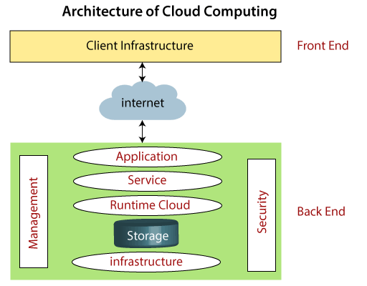

### Front End:

The front end is used by the client. It contains client-side interfaces and applications that are required to access the cloud computing platforms. The front end includes web servers (including Chrome, Firefox, internet explorer, etc.), thin & fat clients, tablets, and mobile devices.

### Back End:

The back end is used by the service provider. It manages all the resources that are required to provide cloud computing services. It includes a huge amount of data storage, security mechanism, virtual machines, deploying models, servers, traffic control mechanisms, etc.

### NIST Cloud Computing Reference Architecture [ Updated ]

### Cloud Consumer:

* Cloud consumer is the main participants of cloud computing environment.
* A cloud consumer is a person or organization that use the cloud services such as SaaS, PaaS and IaaS.
* A cloud consumer browses the service catalog provided by a cloud provider, cloud consumer requests the appropriate service.
* Cloud provider sets up cloud environment for the service and make a contracts with the cloud consumer for the use of the service.
* Cloud consumers need cloud **Service Level Agreement(SLA**).

### Cloud Provider:

* A cloud provider is responsible for making a service available to the cloud consumer. Cloud provider may be a person , team or an organization.
* A Cloud Provider maintain and manages the different cloud computing services for the consumer and makes arrangement to deliver the cloud services to the Cloud Consumers suing network access or internet.

### Cloud Auditor:

A cloud auditor is a dedicated team of technically skilled person that can perform an independent examination or review of cloud service controls with the intent to express strength and weakness of the process and some suggestion or improvement.

Audits are performed to verify the standards of services after checking the evidence.

Major role of a cloud auditor is to evaluate the services provided by a cloud provider against the parameters such as security controls, privacy impact and performance etc.

### Cloud Broker:

Some time services integrations becomes more complex due to which it becomes difficult for the  cloud consumer to manage the cloud service.

In such situation cloud consumer request cloud services from cloud broker. Cloud Broker acts as mediator between consumer and provider.

* A cloud broker manages the delivery of cloud services , their performance and use.
* A cloud broker negotiates relationships between cloud providers and cloud consumers.

## Cloud Deployment Model:

Cloud Deployment Model functions as a virtual computing environment with a deployment architecture that varies depending on the amount of data you want to store and who has access to the infrastructure.

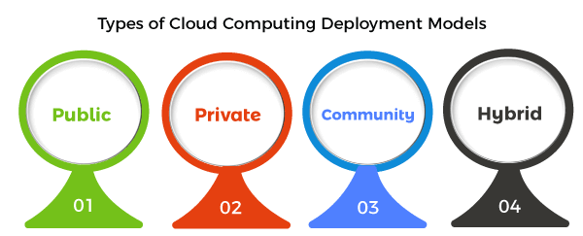

### Public Cloud:

The name says it all. It is accessible to the public. Public deployment models in the cloud are perfect for organizations with growing and fluctuating demands. It also makes a great choice for companies with low-security concerns. Thus, you pay a cloud service provider for networking services, compute virtualization & storage available on the public internet. It is also a great delivery model for the teams with development and testing. Its configuration and deployment are quick and easy, making it an ideal choice for test environments.

### Private Cloud:

Now that you understand what the public cloud could offer you, of course, you are keen to know what a private cloud can do. Companies that look for cost efficiency and greater control over data & resources will find the private cloud a more suitable choice.

It means that it will be integrated with your data center and managed by your IT team. Alternatively, you can also choose to host it externally. The private cloud offers bigger opportunities that help meet specific organizations' requirements when it comes to customization. It's also a wise choice for mission-critical processes that may have frequently changing requirements.

### Community Cloud:

The community cloud operates in a way that is similar to the public cloud. There's just one difference - it allows access to only a specific set of users who share common objectives and use cases. This type of deployment model of cloud computing is managed and hosted internally or by a third-party vendor. However, you can also choose a combination of all three.

### Hybrid Cloud:

As the name suggests, a hybrid cloud is a combination of two or more cloud architectures. While each model in the hybrid cloud functions differently, it is all part of the same architecture. Further, as part of this deployment of the cloud computing model, the internal or external providers can offer resources.

Let's understand the hybrid model better. A company with critical data will prefer storing on a private cloud, while less sensitive data can be stored on a public cloud. The hybrid cloud is also frequently used for 'cloud bursting'. It means, supposes an organization runs an application on-premises, but due to heavy load, it can burst into the public cloud.